**Author name- Harwinder Kaur**

**Student id-100360536**

**Assignment – 3**

**Course number –info 1113**

**Section number-s10**

**Instructor name-dr. abhijit sen**

**Date-november 22, 2018**

**Web url-** [**https://sites.google.com/view/batthfunwithappscom**](https://sites.google.com/view/batthfunwithappscom)

**Github url-** [**https://github.com/HarwinderBatth/testProject**](https://github.com/HarwinderBatth/testProject)

**Use case diagram**

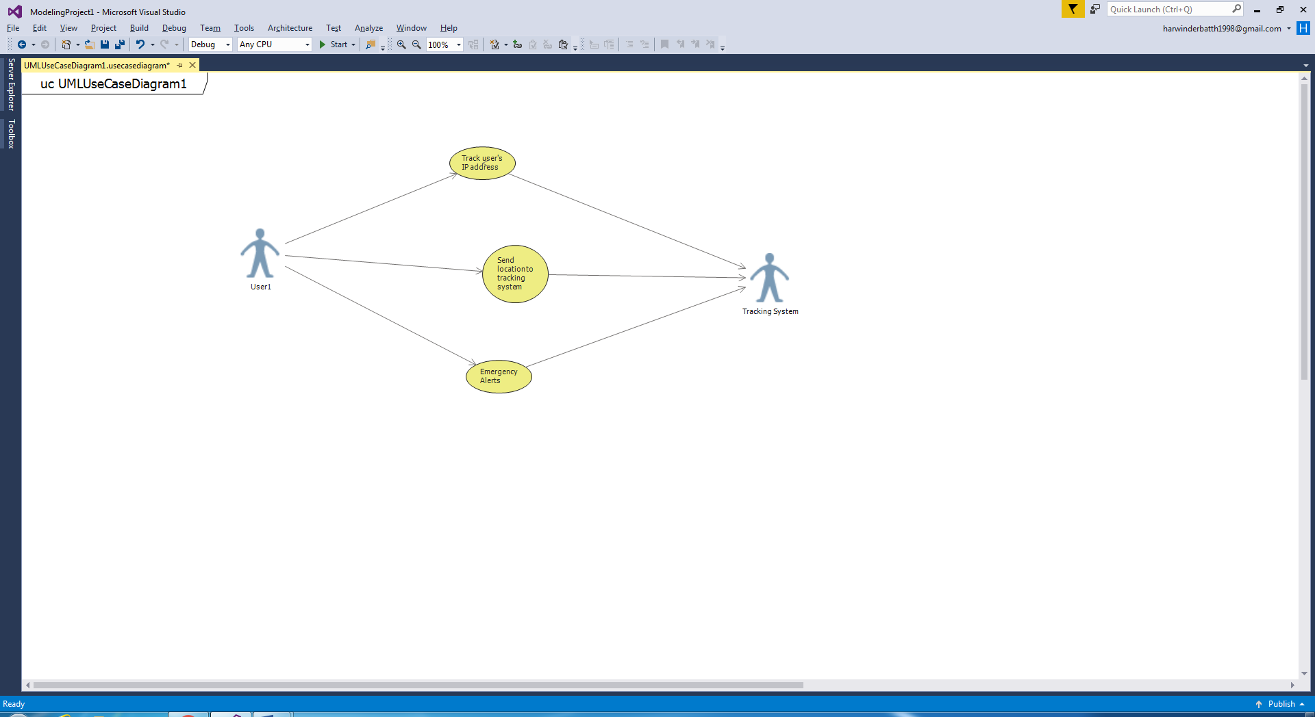

**Use Case Description**

|  |
| --- |
| Use Case Title: Be Found |
| Primary Actor: User 1 |
| Level: Kite |
| Stakeholders: Tracking System and user’s contacts |
| Precondition: App should be in person’s phone |
| Minimal Guarantee: Track the nearest location |
| Success Guarantee: Provides exact location and alerts |
| Trigger: Just single tap on app or by clicking the power button |
| Main Success Scenario:   * User presses the power button. * App will send the notification of the location to the tracking system and triggers emergency alerts as well. |
| Extensions: Can work without Internet. |